# * - Question

This question requires that you evaluate the underlined text to determine if it is correct.  
You have a Power Apps app. You create a new version of the app and then publish the new version. A customer goes through the process of restoring the previous version of the app. In the Version tab for the app, you will see two versions of the app.  
Review the underlined text. If it makes the statement correct, select "No change is needed." If the statement is incorrect, select the answer choice that makes the statement correct.

ANSWER

* A. No change is needed.
* B. one
* C. three
* D. four

# * - Question

A company uses Dynamics 365 Sales. The company uses a browser-based app named Sales Hub.  
You need to ensure that users can access data from mobile devices.  
Which app should users install?

ANSWER

* A. Dynamics 365 Remote Assist
* B. Dynamics 365 Finance
* C. Dynamics 365 Business Central
* D. Dynamics 365 for Phones

# * - Question

You are a customer service manager.  
You need to implement a Power Apps portal that allows customers to submit cases.  
Which type of data source is used?

ANSWER

* A. Dynamics 365 Connector
* B. Microsoft SharePoint
* C. Microsoft Azure Storage
* D. Common Data Service

# * - Question

You create a user-owned custom entity by using Common Data Service.  
For each of the following statements, select Yes if the statement is true. Otherwise, select No.  
NOTE: Each correct selection is worth one point.  
Hot Area:  
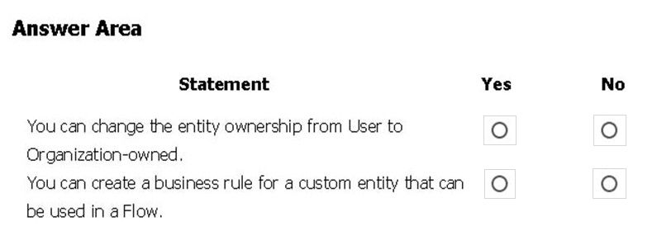

ANSWER

* A. Yes – No
* B. Yes – Yes
* C. No – Yes
* D. No – No

# * - Question

DRAG DROP -  
You need to explain the major components of the Common Data Model (CDM) and their functions.  
Match each term to its definition.  
Instructions: To answer, drag the appropriate term from the column on the left to its definition on the right. Each term may be used once, more than once, or not at all. Each correct match is worth one point.  
NOTE: Each correct selection is worth one point.  
Select and Place:

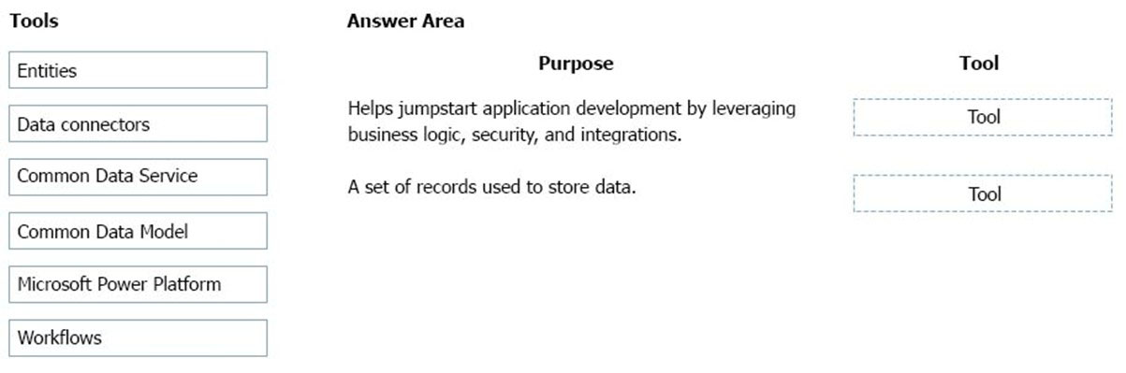

ANSWER

* A. Entities – Data Connectors
* B. Microsoft Power Platform - Entities
* C. Common Data Service – Microsoft Power Platform
* D. Workflows – Common Data Model
* E. Microsoft Power Platform – Common Data Model
* F. Data Connectors - Entities

# * - Question

A distribution company has multiple warehouses.  
Tax rates charged on sales orders need to be calculated based on locality and region.  
You need to recommend a cost-effective solution that can be implemented quickly.  
What should you recommend?

ANSWER

* A. Check AppSource for a tax add-on.
* B. Create alerts in Dynamics 365 Finance for tax table changes.
* C. Implement the Common Data Model.
* D. Run a Power BI report.
* E. Write scripts and code tax updates

# * - Question

DRAG DROP -  
You manage the support team at a rapidly growing company.  
Customers and support technicians need a better experience when logging and responding to support requests. You need more visibility into what the support technicians are doing every week.  
You need to recommend tools to help the company's needs.  
Which tools should you recommend? To answer, drag the appropriate tools to the correct requirements. Each tool may be used once, more than once, or not at all. You may need to drag the split bar between panes or scroll to view content.  
NOTE: Each correct selection is worth one point.  
Select and Place:

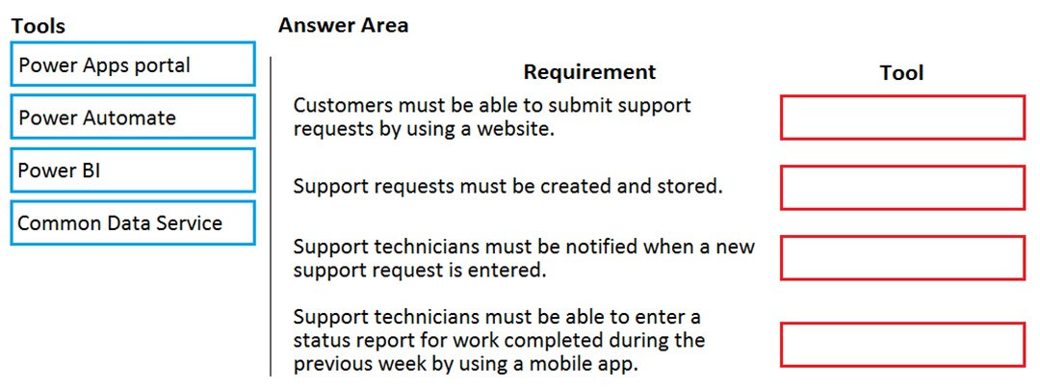

ANSWER

* A. Power Apps Portal – Common Data Service – Power Automate – Power BI
* B. Common Data Service – Power Apps Portal – Power Automate – Power BI
* C. Power Apps Portal – Common Data Service – Power BI – Power Automate
* D. Common Data Service – Power Apps Portal – Power BI – Power Automate
* E. Power Apps Portal – Power BI – Power Automate – Common Data Service

# * - Question

You are building Power Apps apps that use both Dynamics 365 Sales and Microsoft 365.  
For each of the following statements, select Yes if the statement is true. Otherwise, select No.  
NOTE: Each correct selection is worth one point.  
Hot Area:

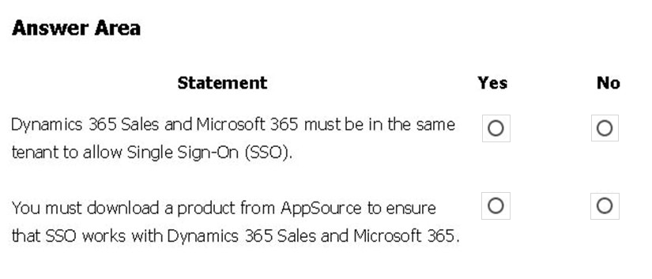

ANSWER

* A. No – No
* B. Yes – No
* C. Yes – Yes
* D. No – Yes

# * - Question

You need to implement Microsoft Business Applications along with the Microsoft Power platform.  
Which three Microsoft products are part of the Power platform? Each correct answer presents a complete solution.  
NOTE: Each correct selection is worth one point.

ANSWER

* A. Microsoft Power Apps
* B. Azure Active Directory
* C. Microsoft Flow
* D. Azure Machine Learning
* E. Microsoft Power BI

# * - Question

HOTSPOT -  
A company plans to implement Power Platform apps. The company does not plan to use any development tools or plug-ins.  
Which actions can you perform?  
For each of the following statements, select Yes if the statement is true. Otherwise, select No.  
NOTE: Each correct selection is worth one point.  
Hot Area:

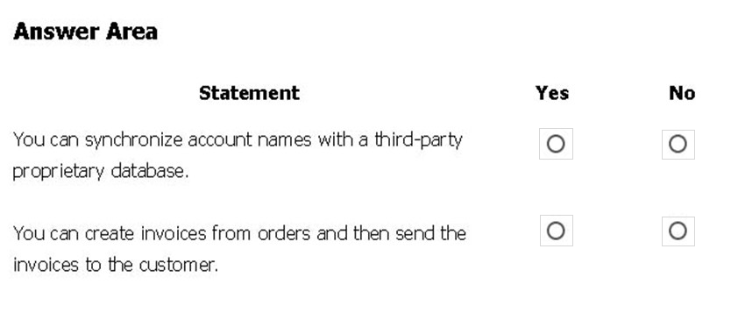

ANSWER

* A. No – No
* B. Yes – No
* C. Yes – Yes
* D. No – Yes

# * - Question

A large retail company implements Power Apps, Microsoft Flow, and the Common Data Service.  
The board of directors is asking whether users are finding value in the technology. The company would like to measure and report usage of the software.  
You need to recommend a tool to determine software usage.  
What should you recommend?

ANSWER

* A. Microsoft Intune
* B. Azure Stream Analytics
* C. Power Platform Analytics
* D. Dynamics 365 Product Insights

# * - Question

DRAG DROP -  
A company uses Power Apps.  
You need to perform administrative tasks for the company.  
Which admin centers should you use? To answer, drag the appropriate admin centers to the correct requirements. Each admin center may be used once, more than once, or not at all. You may need to drag the split bar between panes or scroll to view content.  
NOTE: Each correct selection is worth one point.  
Select and Place:

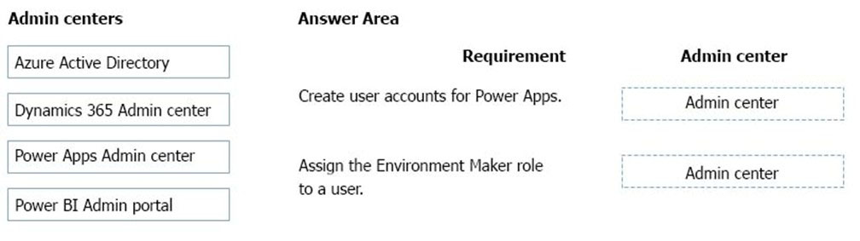

ANSWER

* A. Azure Active Directory – Power Apps Admin Center
* B. Azure Active Directory – Dynamics 365 Admin Center
* C. Dynamics 365 Admin Center – Azure Active Directory
* D. Power Apps Admin Center – Azure Active Directory
* E. Power BI Admin portal – Power Apps Admin Center
* F. Power Apps Admin Center – Dynamics 365 Admin Center

# * - Question

HOTSPOT -  
A rapidly growing company produces Office 365 licenses for all employees. The company wants to empower users to build apps, automate business processes, and analyze data without requiring IÐ¢ expertise or development skills and without increasing IT expenses and dependencies.  
You need to recommend tools so that users can accomplish specific tasks.  
Which tools should you recommend? To answer, select the appropriate options in the answer area.  
NOTE: Each correct selection is worth one point.  
Hot Area:

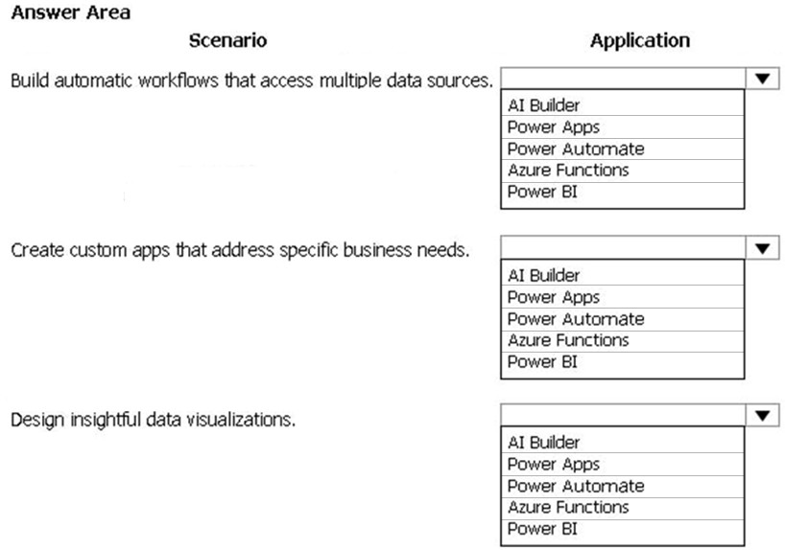

ANSWER

* A. Power Automate – Power Apps – Power BI
* B. AI Builder – Power Apps – Azure Functions
* C. Power Apps – Power BI – Power Automate
* D. Azure Functions – AI Builder – Power Apps
* E. Power BI – Azure Functions – AI Builder
* F. Power Automate – Power Apps – AI Builder

# * - Question

HOTSPOT -  
A company plans to use Power Platform to build apps which address specific business challenges.  
You need to recommend the appropriate types of Power Apps to use.  
What should you recommend? To answer, select the appropriate option in the answer area.  
NOTE: Each correct selection is worth one point.  
Hot Area:

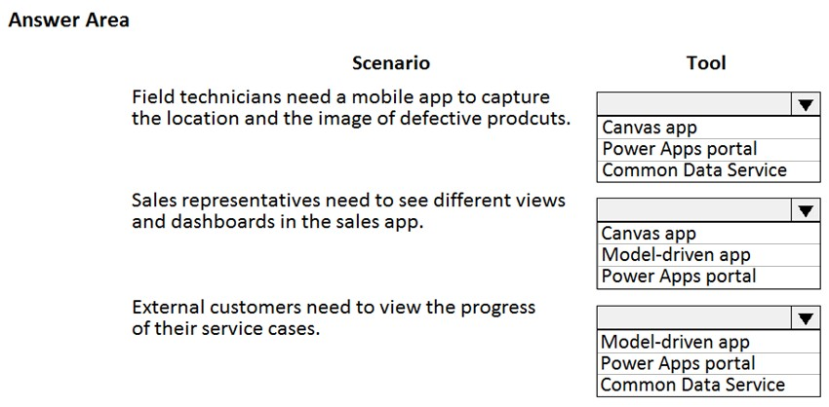

ANSWER

* A. Canvas App – Model-driven app – Power Apps portal
* B. Power Apps Portal – Canvas App – Common Data Service
* C. Common Data Service – Power Apps Portal – Model-driven app
* D. Canvas App – Model-driven app – Common Data Service
* E. Common Data Service – Model-driven app – Power Apps portal
* F. Canvas App – Canvas App – Power Apps portal

# * - Question

HOTSPOT -  
You are creating a model-driven Power Apps app. You want to ensure that the app can be used by individuals who have vision impairments.  
For each of the following statements, select Yes if the statement is true. Otherwise, select No.  
NOTE: Each correct selection is worth one point.  
Hot Area:

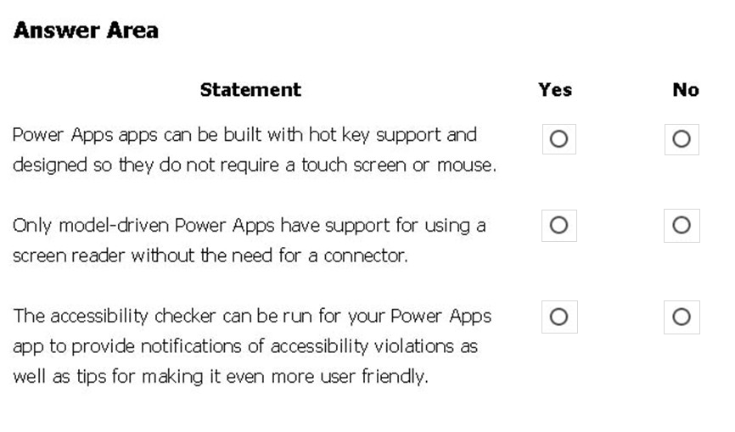

ANSWER

* A. Yes – No – Yes
* B. Yes – No – No
* C. Yes – Yes – Yes
* D. No – Yes – Yes
* E. No – No – No
* F. Yes – Yes – No

# * - Question

DRAG DROP -  
A bank uses Power Platform apps and flows to support business processes.  
The company would like to use historical client data to predict whether a client's loan application is likely to be approved or rejected.  
You need to use AI Builder to implement the solution.  
Which four actions should you perform in sequence? To answer, move the appropriate actions from the list of actions to the answer area and arrange them in the correct order.  
Select and Place:

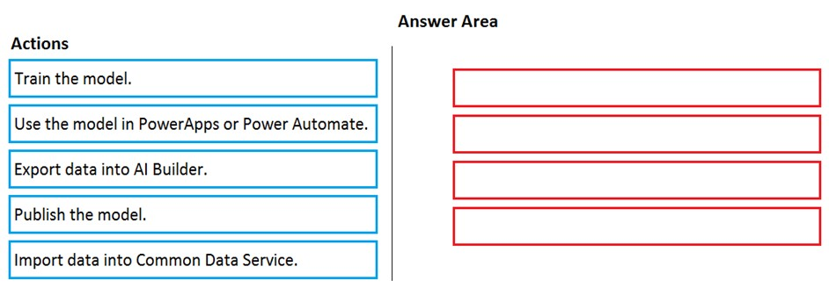

ANSWER

* A. Import data into Common Data Service – Train the model – Publish the model – Use the model in PowerApps or Power Automate
* B. Train the model – Import data into Common Data Service – Publish the model – Use the model in PowerApps or Power Automate
* C. Publish the model – Import data into Common Data Service – Train the model –Use the model in PowerApps or Power Automate
* D. Import data into Common Data Service – Train the model – Use the model in PowerApps or Power Automate – Publish the model
* E. Export data into AI Builder – Train the model – Publish the model – Use the model in PowerApps or Power Automate
* F. Import data into Common Data Service – Export data into AI Builder – Publish the model – Use the model in PowerApps or Power Automate

# * - Question

DRAG DROP -  
A company plans to implement solutions that use Common Data Service as a data storage.  
You need to recommend features to meet the company's needs.  
Which features should you recommend? To answer, drag the appropriate features to the correct requirements. Each feature may be used once, more than once, or not at all. You may need to drag the split bar between panes or scroll to view content.  
NOTE: Each correct selection is worth one point.  
Select and Place:  
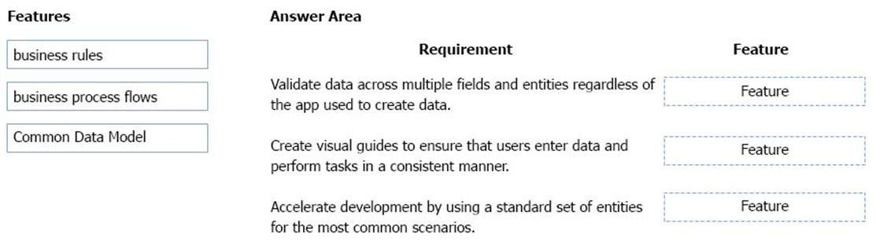

ANSWER

* A. business rules – business process flow – Common Data Model
* B. business rules – business rules – Common Data Model
* C. business rules – Common Data Model– business process flow
* D. Common Data Model– business process flow – business rules
* E. business process flow – business rules – Common Data Model
* F. Common Data Model – business process flow – business rules

# * - Question

A business is evaluating AI Builder.  
Which actions can you perform?  
For each of the following statements, select Yes if the statement is true. Otherwise, select No.  
NOTE: Each correct selection is worth one point.  
Hot Area:  
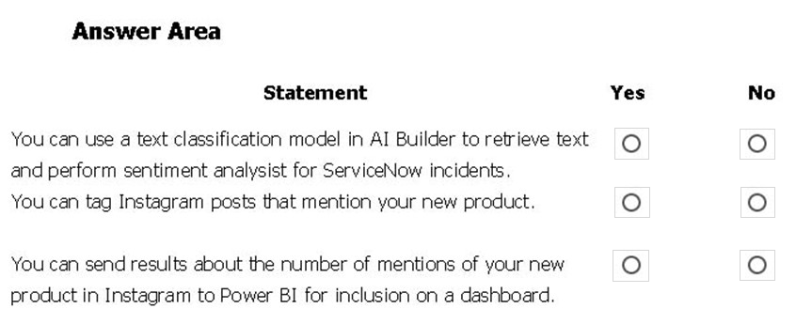

ANSWER

* A. Yes – Yes – Yes
* B. Yes – No – No
* C. Yes – No – Yes
* D. No – Yes – Yes
* E. No – No – No
* F. Yes – Yes – No

# * - Question

You create a business rule on contact entity to enforce the requirement that users must enter either a telephone number, fax number, or an email when creating a new record.  
The company decides to remove fax number from the condition.  
You need to update the business rule.  
What are two ways of achieving the goal? Each correct answer presents a complete solution.  
NOTE: Each correct selection is worth one point.

ANSWER

* A. Save a copy of the rule and change the condition. Deactivate and delete the original rule.
* B. Deactivate the business rule and change the condition.
* C. Take a snapshot of the business rule and change the condition.
* D. Change the condition and activate the change.

# * - Question

A coworker is creating an app in Power Apps and needs to automatically synchronize data from an external source. The coworker is unable to locate a suitable  
Microsoft approved connector template in AppSource.  
You need to recommend a solution for the coworker.  
What should you recommend?

ANSWER

* A. Create a custom connector.
* B. Ask the outside source to send you the data once a week.
* C. Use Microsoft Flow to connect to the database.
* D. Open a ticket with Microsoft and request a new connector.
* E. Use Microsoft Azure Service Bus.

# * - Question

A toy company creates a text classification model in AI Builder to monitor customer feedback for specific key words.  
When negative feedback is received for a toy, the company wants to proactively perform engineering reviews for the toy and schedule additional training sessions for workers who produce the toy.  
What are two possible ways to achieve the goal? Each correct answer presents a complete solution.  
NOTE: Each correct selection is worth one point.

ANSWER

* A. Create a canvas app.
* B. Implement the Virtual Agent.
* C. Build a Power Automate flow.
* D. Use the Common Data Model.

# * - Question

A company plans to use Power BI to visualize data from business systems.  
For each of the following statements, select Yes if the statement is true. Otherwise, select No.  
NOTE: Each correct selection is worth one point.  
Hot Area:  
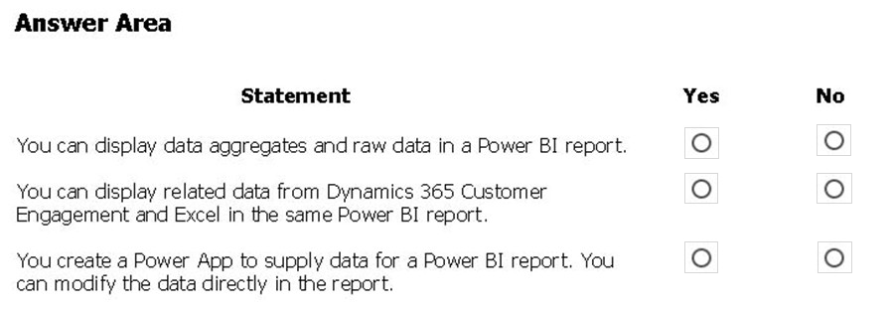

ANSWER

* A. Yes – No – Yes
* B. Yes – No – No
* C. Yes – Yes – Yes
* D. No – Yes – Yes
* E. No – No – No
* F. Yes – Yes – No

# * - Question

A company is evaluating ways that they can implement AI Builder.  
For which two scenarios can you use AI Builder? Each correct selection presents a complete solution.  
NOTE: Each correct selection is worth one point.

ANSWER

* A. Send emails to all al users who subscribe to a service.
* B. Synchronize data from an external database.
* C. Collect data from several data sources and display a dashboard that shows trending data.
* D. Interpret images and perform an action on the image.

# * - Question

HOTSPOT -  
A company plans to create Power Platform apps that consume industry-standard and proprietary data sources.  
For each of the following statements, select Yes if the statement is true. Otherwise, select No.  
NOTE: Each correct selection is worth one point.  
Hot Area:  
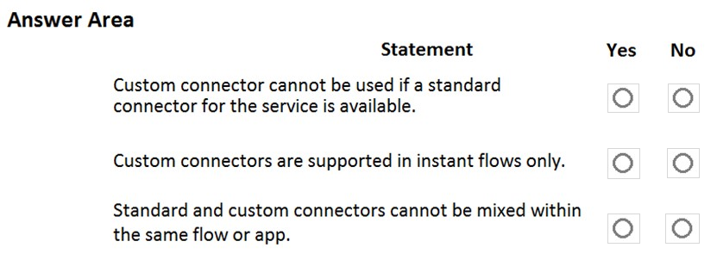

ANSWER

* A. No – No – No
* B. Yes – No – No
* C. Yes – Yes – Yes
* D. No – Yes – Yes
* E. Yes – No – Yes
* F. Yes – Yes – No

# * - Question

HOTSPOT -  
A company is evaluating Power Platform and has questions about the role that Common Data Service plays in using Power Apps and Power Automate.  
For each of the following statements, select Yes if the statement is true. Otherwise, select No.  
NOTE: Each correct selection is worth one point.  
Hot Area:  
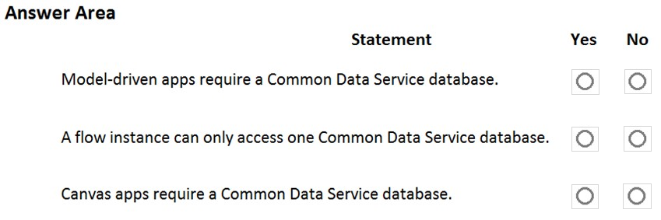

ANSWER

* A. Yes – Yes – Yes
* B. Yes – No – No
* C. Yes – No – Yes
* D. No – Yes – Yes
* E. No – No – No
* F. Yes – Yes – No

# * - Question

HOTSPOT -  
A company plans to create a Common Data Service environment.  
For each of the following statements, select Yes if the statement is true. Otherwise, select No.  
NOTE: Each correct selection is worth one point.  
Hot Area:  
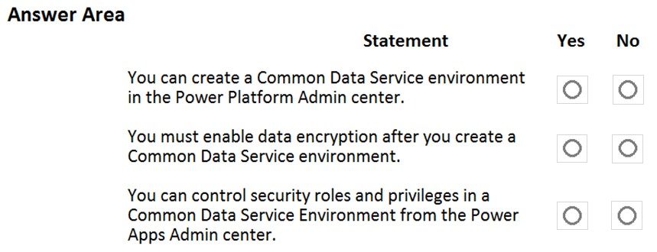

ANSWER

* A. Yes – No – Yes
* B. Yes – No – No
* C. Yes – Yes – Yes
* D. No – Yes – Yes
* E. No – No – No
* F. Yes – Yes – No

# * - Question

A company plans to use AI Builder to help improve business performance.  
You need to determine which AI Models are available for use.  
Which three types of models can you use? Each correct answer presents a complete solution.  
NOTE: Each correct selection is worth one point.

ANSWER

* A. linear regression
* B. binary classification
* C. object detection
* D. anomaly detection
* E. text classification

# * - Question

A company uses Microsoft 365 and Dynamics 365 Sales. The company does not have any developers on its staff.  
You need to explain to the executives the benefits of using Power Platform apps.  
What are two benefits? Each correct answer presents a complete solution.  
NOTE: Each correct selection is worth one point.

ANSWER

* A. Users can send emails from Dynamics 365 Sales to their personal email addresses.
* B. Users can create Power Apps to create apps for different departments.
* C. Users can use Power Automate to share information between Microsoft 365 and Dynamics 365 Sales.
* D. The company must unify all the mobile devices to one vendor.

# * - Question

HOTSPOT -  
A company needs to create several workflows and applications to help streamline their sales operations.  
You need to determine which applications are appropriate for given scenarios.  
Which applications should you use? To answer, select the appropriate options in the answer area.  
NOTE: Each correct selection is worth one point.  
Hot Area:

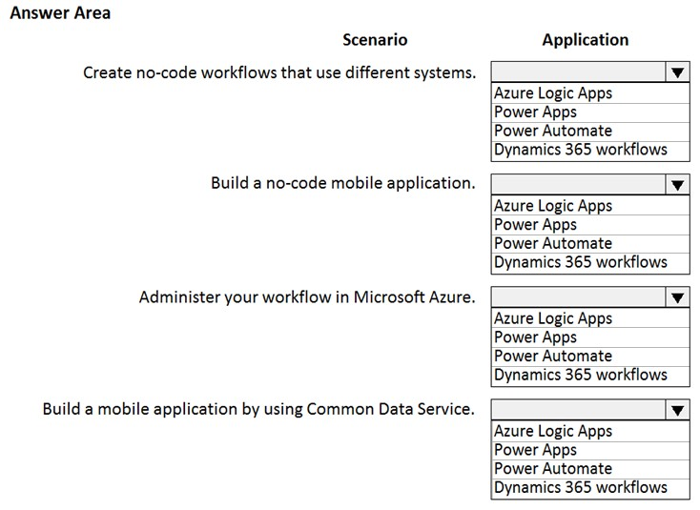

ANSWER

* A. Power Automate – Power Apps – Azure Logic Apps – Power Apps
* B. Power Apps – Power Automate – Azure Logic Apps – Power Apps
* C. Azure Logic Apps – Power Automate – Power Apps – Dynamics 365 workflows
* D. Dynamics 365 workflows – Power Apps – Azure Logic Apps – Power Apps
* E. Power Automate – Power Apps – Dynamics 365 workflows – Power Apps
* F. Power Automate – Azure Logic Apps – Power Apps – Power Automate

# * - Question

A company manages a chain of retail stores. The company stores a list of retail store names and numbers in one Power BI table. The company stores sales transaction data including a transaction ID in another table. The transaction ID includes the store number.  
You need to show the store name for all retail transactions in all Power BI reports.  
Which tool should you use?

ANSWER

* A. Query Editor
* B. Power BI Service
* C. Microsoft Excel
* D. Data Connector

# * - Question

DRAG DROP -  
A company is using Power BI to build visualizations.  
The company's IT support team needs to know when to install Power BI Desktop on users' computers and where the Power BI Service will suffice to perform tasks.  
You need to recommend solutions for the company.  
What should you recommend? To answer, drag the appropriate components to the correct requirements. Each component may be used once, more than once, or not at all. You may need to drag the split bar between panes or scroll to view content.  
NOTE: Each correct selection is worth one point.

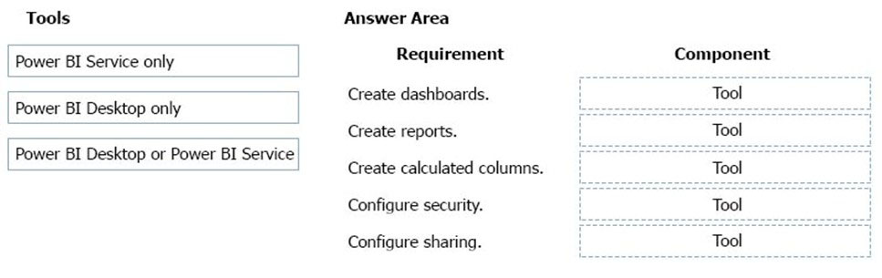

ANSWER

* A. Power BI Service only – Power BI Desktop or Power BI Service – Power BI Desktop only – Power BI Desktop or Power BI Service – Power BI Desktop only
* B. Power BI Service only – Power BI Desktop only – Power BI Desktop or Power BI Service – Power BI Desktop or Power BI Service – Power BI Desktop only
* C. Power BI Service only – Power BI Desktop or Power BI Service – Power BI Desktop only – Power BI Desktop or Power BI Service – Power BI Desktop only
* D.  Power BI Desktop only – Power BI Desktop or Power BI Service – Power BI Desktop only – Power BI Desktop or Power BI Service – Power BI Service only
* E. Power BI Service only – Power BI Desktop only – Power BI Desktop or Power BI Service – Power BI Desktop only – Power BI Desktop only
* F. Power BI Service only – Power BI Service only – Power BI Desktop only – Power BI Desktop or Power BI Service – Power BI Desktop only

# * - Question

DRAG DROP -  
A company plans to create an information portal that managers can use to view critical information about their teams.  
You need to recommend the type of Power BI components that the company should use.  
What should you recommend? To answer, drag the appropriate component types to the correct requirements. Each component type may be used once, more than once, or not at all. You may need to drag the split bar between panes or scroll to view content.  
NOTE. Each correct selection is worth one point.  
Select and Place:  
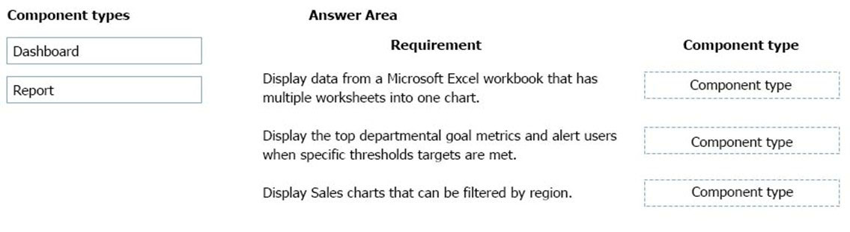

ANSWER

* A. Report – Dashboard – Report
* B. Report – Dashboard – Dashboard
* C. Dashboard – Dashboard – Report
* D. Report – Report – Report
* E. Report – Dashboard – Report
* F. Report – Report – Dashboard

# * - Question

HOTSPOT -  
You have a Power BI report.  
For each of the following statements, select Yes if the statement is true. Otherwise, select No.  
NOTE: Each correct selection is worth one point.  
Hot Area:  
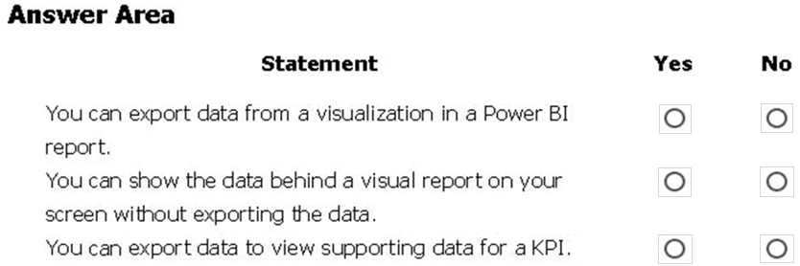

ANSWER

* A. Yes – No – Yes
* B. Yes – No – No
* C. Yes – Yes – Yes
* D. No – Yes – Yes
* E. No – No – No
* F. Yes – Yes – No

# * - Question

You create a Power BI dashboard that displays data from Dynamics 365 Customer Engagement.  
You need to share the Power BI dashboard with coworkers.  
What are three possible ways to achieve the goal? Each correct answer presents a complete solution.  
NOTE: Each correct selection is worth one point.

ANSWER

* A. Create a Power BI workspace and grant coworkers permissions.
* B. Publish the dashboard as an app to your coworkers.
* C. Export the data into Common Data Service for others to manipulate in Power BI.
* D. Export the data to Microsoft Excel for coworkers to import and view in Power BI.
* E. Embed reports in your company's internal web portal.

# * - Question

Your company has an on-premises Microsoft SQL Server database that contains legacy sales data. You must display information from the database in a new  
Power Apps app.  
You need to establish a secure connection between the database and the app.  
What should you use?

ANSWER

* A. Data source
* B. App
* C. Data gateway
* D. Power Automate

# * - Question

A recent update has been made to a canvas app.  
The update causes a negative impact to users.  
You need to roll back the app to a previous version.  
What should you do?

ANSWER

* A. Restore the previous version of the app.
* B. Uninstall the app for all users and reinstall by using the package from a previous version.
* C. Deactivate the live app, import the previous version of the app, and then activate the app.
* D. Delete the app and create a new app based on the previous version.

# * - Question

DRAG DROP -  
A company needs to create a series of mobile applications to empower their field engineers to accomplish several tasks with varying degrees of complexity.  
Match each app type to its definition. To answer, drag the appropriate app type from the column on the left to its definition on the right. Each app type may be used once, more than once, or not at all.  
NOTE: Each correct match is worth one point.  
Select and Place:  
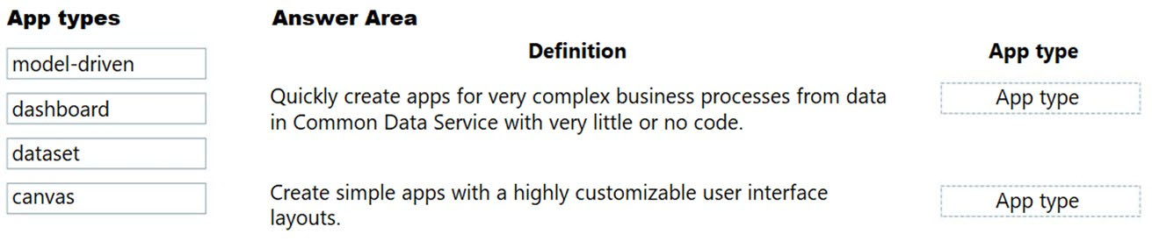

ANSWER

* A. model-driven – canvas
* B. canvas – model-driven
* C. dashboard – dataset
* D. canvas – dashboard
* E. canvas – canvas
* F. model-driven – model-driven

# * - Question

HOTSPOT -  
A user is starting to learn about Power Apps.  
Which objects should you use? To answer, select the appropriate options in the answer area.  
NOTE: Each correct selection is worth one point.  
Hot Area:  
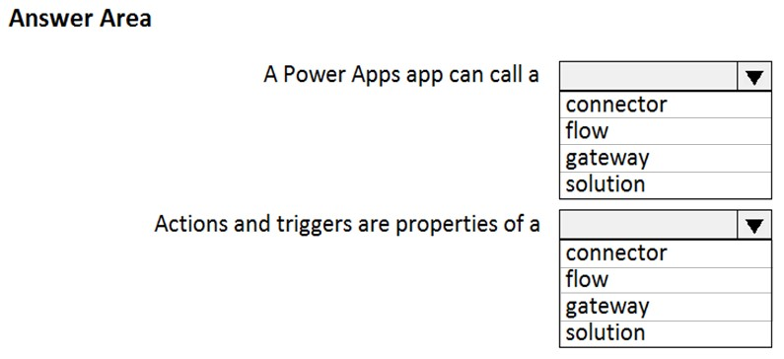

ANSWER

* A. connector – flow
* B. connector – gateway
* C. gateway – flow
* D. flow – solution
* E. solution– flow
* F. gateway – connector

# * - Question

What is a benefit of deploying Microsoft 365 and Dynamics 365 apps in the same tenant?

ANSWER

* A. You do not need to manually back up data.
* B. Both will use the same time zone.
* C. You can use Power BI to display data that comes from both environments.
* D. You can implement Single Sign-On (SSO).

# * - Question

A company runs a call center to handle customer support inquires.  
The company tracks metrics including the number of incoming calls, call resolution rates, and escalations. The company wants to display the metrics on a shared screen that is visible to all call center staff.  
You need to recommend a solution for the company.  
Which Power Platform feature should you recommend?

ANSWER

* A. AI Builder
* B. Power Automate
* C. Power Apps
* D. Power BI

# * - Question

HOTSPOT -  
You are a regional sales manager for a large internet retailer. You create a series of Power BI reports and dashboards to help sales associates be more productive and increase sales.  
Sales are not increasing as expected.  
You need to determine if the new reports are being used and send emails to sales associates to provide guidance on how to use the reports and dashboards.  
Which features should you use? To answer, select the appropriate options in the answer area.  
NOTE: Each correct selection is worth one point.  
Hot Area:  
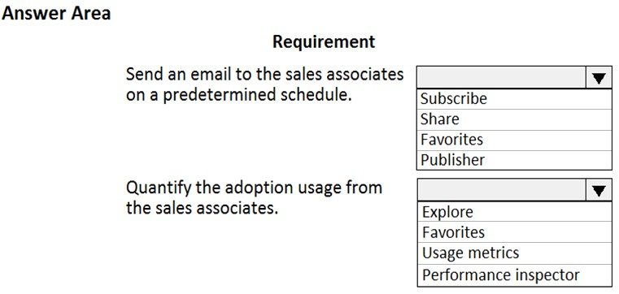

ANSWER

* A. subscribe – Usage metrics
* B. subscribe – Performance inspector
* C. share – Usage metrics
* D. Favorites– Explore
* E. Publisher– Favorites

# * - Question

You are creating Power BI reports.  
You need to choose which filters you can use for reports.  
Which three types of filters can you use? Each correct answer presents a complete solution.  
NOTE: Each correct selection is worth one point.

ANSWER

* A. drill-down
* B. automatic
* C. database
* D. manual
* E. external

# * - Question

A manufacturing company uses Internet of Things (IoT) devices to monitor the temperature in different parts of their warehouse.  
The current IoT monitoring software is extremely outdated and is not user friendly.  
You need to view near-real time information from the IoT devices in Power BI Service dashboards.  
Which tool should you use?

ANSWER

* A. Scheduled refresh dataset
* B. Streaming dataset
* C. Content Pack dataset
* D. Power BI dataflows
* E. Quick Insights

# * - Question

This question requires that you evaluate the underlined text to determine if it is correct.  
You have a Power BI report with a page named RevReceived. The page shows revenue received by your company. You want to create an almost identical page that shows net revenue instead of gross revenue. To accomplish this task, you modify the RevReceived page.  
Review the underlined text. If it makes the statement correct, "No change is needed". If the statement is incorrect, select the answer choice that makes the statement correct.

ANSWER

* A. No change is needed.
* B. duplicate the RevReceived page.
* C. import the RevReceived page.
* D. copy the visuals from RevReceived to a new page.

# * - Question

DRAG DROP -  
A company plans to implement Power BI to analyze retail operations data.  
You need to recommend solutions for the company.  
Which Power BI components should the company use? To answer, drag the appropriate Power BI components to the correct requirements. Each Power BI component may be used once, more than once, or not at all. You may need to drag the split bar between panes or scroll to view content.  
NOTE: Each correct selection is worth one point.  
Select and Place:  
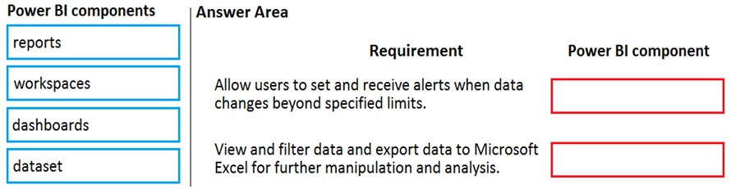

ANSWER

* A. workspaces – dataset
* B. dataset – workspaces
* C. workspaces – dashboards
* D. reports – dataset
* E. dataset – reports
* F. reports – dashboards

# * - Question

You create a set of dashboards and reports for a project team that combines data from different sources in Power BI. Some of the data is considered sensitive.  
You need to distribute the dashboards and reports securely to the team.  
What should you create?

ANSWER

* A. a custom data connector
* B. a published app
* C. a Microsoft flow
* D. a Power BI workspace

# * - Question

DRAG DROP -  
You create a Power BI dashboard.  
Match each option to its function. To answer, drag the appropriate option from the column on the left to its function on the right. Each option may be used once, more than once, or not at all.  
NOTE: Each correct match is worth one point.  
Select and Place:  
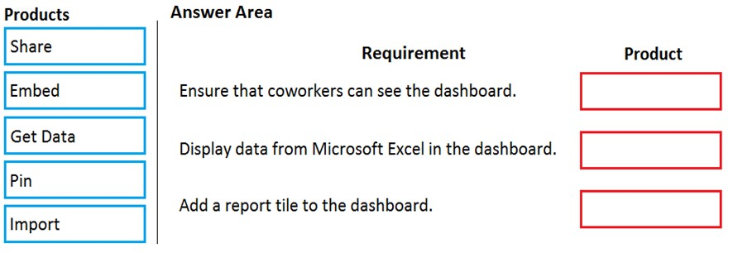

ANSWER

* A. Share – Get Data – Pin
* B. Get Data – Pin – Share
* C. Pin – Share – Get Data
* D. Embed – Import – Pin
* E. Pin – reports – Embed
* F. Share – Pin – Import

# * - Question

You are using Dynamics 365 Sales.  
You need to pull data into a Power BI report for your team. The City and State columns must be combined to form one column on the report.  
Which function would you use? Each correct answer presents a complete solution.  
NOTE: Each correct selection is worth one point.

ANSWER

* A. Use Power Query to merge columns.
* B. Import the data.
* C. Export data to Microsoft Excel.
* D. Create a view.

# * - Question

A carpet cleaning company uses Dynamics 365 Sales.  
The process for entering customer information during onsite sales calls is very complicated. The company wants a simplified screen that allows salespeople to capture the customer name, phone number, and other information while speaking to the customer.  
You need to recommend a solution that works on various types of mobile devices.  
What should you recommend?

ANSWER

* A. Common Data Service
* B. Power Automate
* C. AI Builder
* D. Canvas app
* E. Power BI

# * - Question

DRAG DROP -  
A company is building a Power Apps portal.  
You need to select out-of-the-box portal types to meet the company's requirements.  
Which portal types should you use? To answer, drag the appropriate portal types to the correct requirements. Each portal type may be used once, more than once, or not at all. You may need to drag the split bar between panes or scroll to view content.  
NOTE: Each correct selection is worth one point.  
Select and Place:  
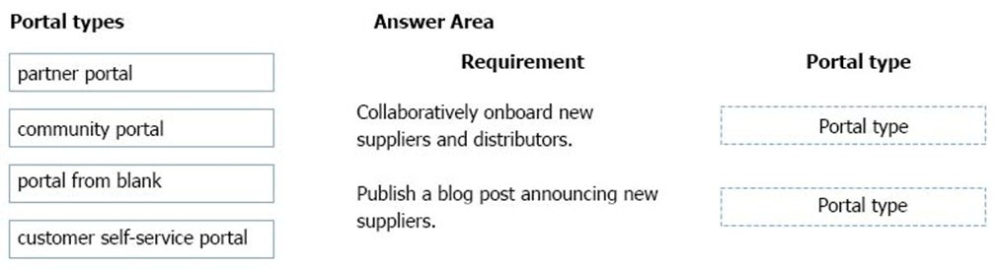

ANSWER

* A. partner portal – community portal
* B. community portal – partner portal
* C. portal from blank – customer self-service portal
* D. partner portal – portal from blank
* E. community portal – customer self-service portal
* F. customer self-service portal – portal from blank

# * - Question

HOTSPOT -  
A user is trying to understand the differences between the various ways apps can be built by using Power Apps.  
For each of the following statements, select Yes if the statement is true. Otherwise, select No.  
NOTE: Each correct selection is worth one point.  
Hot Area:  
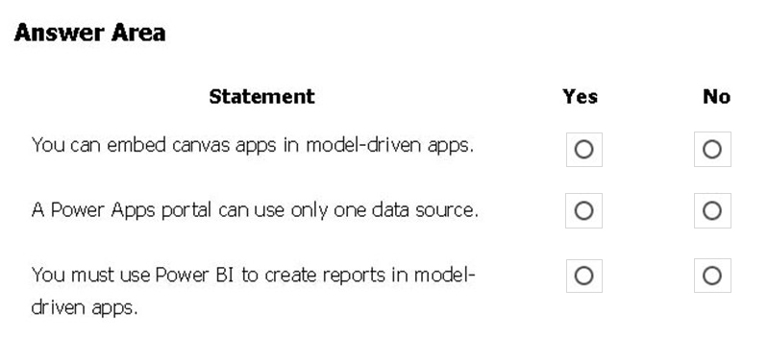

ANSWER

* A. Yes – No – Yes
* B. Yes – No – No
* C. Yes – Yes – Yes
* D. No – Yes – Yes
* E. No – No – No
* F. Yes – Yes – No

# * - Question

HOTSPOT -  
A user is creating their first canvas app in Power Apps.  
The user does not know what types of controls they can include.  
You need to recommend solutions for the user.  
Which types of controls should you recommend using in Power Apps? To answer, select the appropriate options in the answer area.  
NOTE: Each correct selection is worth one point.  
Hot Area:  
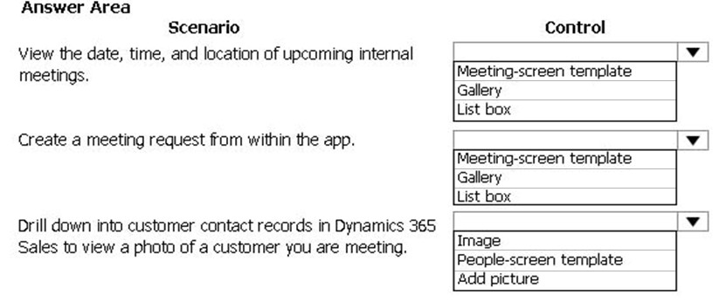

ANSWER

* A. Gallery – Meeting-screen template – Image
* B. Meeting-screen template – Gallery – Image
* C. Meeting-screen template – Image – Gallery
* D. List box – Image – Gallery
* E. List box – Image – Add picture
* F. Gallery – Meeting-screen template – Add Picture

# * - Question

HOTSPOT -  
You are designing a Power Apps solution that allows users to upload a status report directly to the company Microsoft SharePoint project management site from their mobile device.  
For each of the following statements, select Yes it the statement is true. Otherwise, select No.  
NOTE: Each correct selection is worth one point.  
Hot Area:  
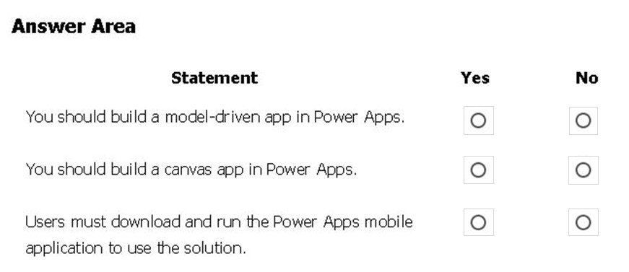

ANSWER

* A. Yes – No – No
* B. Yes – No – Yes
* C. Yes – Yes – Yes
* D. No – Yes – Yes
* E. No – No – No
* F. Yes – Yes – No

# * - Question

A company uses Dynamics 365 Supply Chain Management.  
The company wants to build customer user interfaces that add additional functionality.  
You need to recommend a solution for the company.  
What should you recommend?

ANSWER

* A. Power BI
* B. Power Apps canvas apps
* C. AI Builder
* D. Microsoft Flow

# * - Question

DRAG DROP -  
A company plans to implement Power Apps in a Power Platform environment.  
You need to implement other required components.  
Match each option to its function. To answer, drag the appropriate option from the column on the left to its function on the right. Each option may be used once, more than once, or not at all.  
NOTE: Each correct match is worth one point.  
Select and Place:  
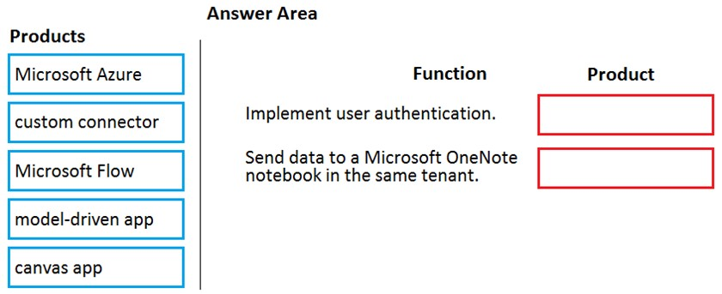

ANSWER

* A. Microsoft Azure – Microsoft Flow
* B. Microsoft Flow – Microsoft Azure
* C. custom connector – Microsoft Flow
* D. model-driven app – canvas app
* E. canvas app – Microsoft Azure
* F. Microsoft Azure – model-driven app

# * - Question

DRAG DROP -  
A company plans to create canvas apps.  
What is the minimum number of connectors required? To answer, drag the appropriate number of connectors to the correct drop scenarios. Each number of connectors may be used once, more than once, or not at all. You may need to drag the split bar between panes or scroll to view content.  
NOTE: Each correct selection is worth one point.  
Select and Place:  
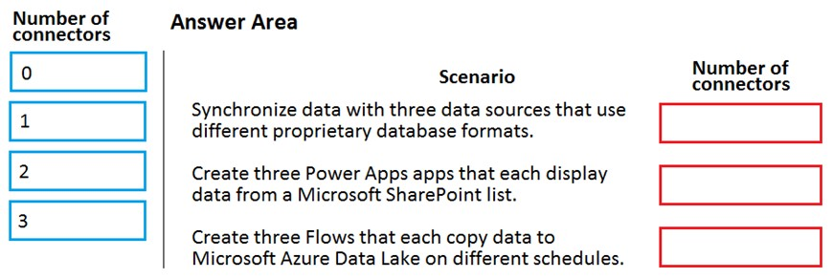

ANSWER

* A. 1 – 3 – 3
* B. 1 – 2 – 3
* C. 1 – 1 – 3
* D. 0 – 1 – 2
* E. 3 – 3 – 2
* F. 2 – 3 – 1

# * - Question

You create a Power Apps canvas app.  
You need to ensure that your coworkers can run the app.  
What should you do?

ANSWER

* A. Share the app.
* B. Send the URL for the app to coworkers.
* C. Add a license for the app.
* D. Create a Flow for the app.

# * - Question

A company uses Microsoft 365, Power Platform, and Dynamics 365. You do not assign permissions to any licensed users.  
Users are able to create and edit Power Apps canvas apps.  
In which environment are users creating and editing the apps?

ANSWER

* A. Production
* B. Default
* C. Sandbox
* D. None

# * - Question

A company is creating a canvas app to display data from a legacy system that is located on the company's internal network.  
You need to connect to the data.  
What should you use?

ANSWER

* A. custom connector
* B. content pack
* C. data gateway
* D. Power Automate

# * - Question

You are creating a canvas app.  
You need to configure the app.  
Which two objects are provided by the connector? Each correct answer presents a complete solution.  
NOTE: Each correct selection is worth one point.

ANSWER

* A. customizations
* B. data sources
* C. actions
* D. tables

# * - Question

DRAG DROP -  
A company is considering implementing PowerApps to help manage business processes. Users are trying to understand the purposes and benefits of PowerApps components.  
Match each benefit to its tool. To answer, drag the appropriate benefit from the column on the left to its tool on the right. Each benefit may be used once, more than once, or not at all.  
NOTE: Each correct selection is worth one point.  
Select and Place:  
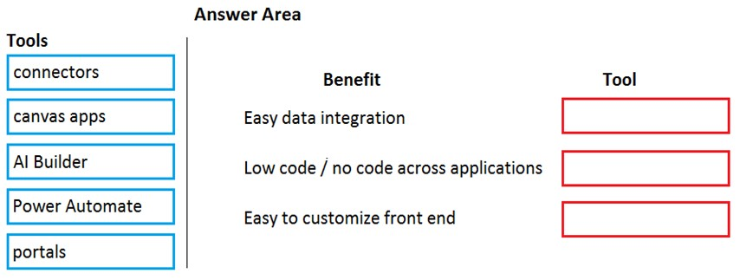

ANSWER

* A. connectors – AI Builder – canvas apps
* B. Power Automate – AI Builder – canvas apps
* C. portals – AI Builder – canvas apps
* D. connectors – canvas app – portals
* E. AI Builder – connectors – canvas app
* F. portals – Power Automate – connectors

# * - Question

DRAG DROP -  
A company plans to build new apps for the business to allow employees to work more efficiently.  
You need to recommend the appropriate types of Power Apps to meet the company's requirements.  
To answer, drag the appropriate app types to the correct requirements. Each app type may be used once, more than once, or not at all. You may need to drag the split bar between panes or scroll to view content.  
NOTE: Each correct selection is worth one point.  
Select and Place:  
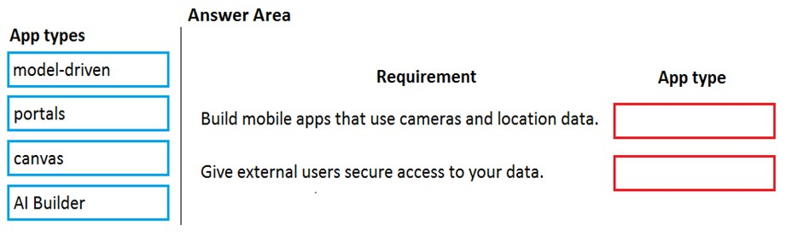

ANSWER

* A. canvas – portals
* B. AI Builder – portals
* C. portals – canvas
* D. model-driven – canvas
* E. canvas – model-driven
* F. portals – AI Builder

# * - Question

A company is considering implementing Power Platform.  
For which three scenarios should you consider implementing Power Apps portals? Each correct answer presents a complete solution.  
NOTE: Each correct selection is worth one point.

ANSWER

* A. a customer support website that includes knowledge search and support for document uploads
* B. a public website that supports multi-lingual communities with forums and blogs support
* C. an online store with e-commerce requirements including payment processing
* D. a secure website for vendors accessing data stored in Common Data Service
* E. an internal website for employees to access selected data from Dynamics 365 Finance

# * - Question

DRAG DROP -  
A company is building a model-driven app.  
You need to create and configure the objects needed for the app.  
Which component categories should you use? To answer, drag the appropriate component categories to the correct objects. Each component category may be used once, more than once, or not at all. You may need to drag the split bar between panes or scroll to view content.  
NOTE: Each correct selection is worth one point.  
Select and Place:  
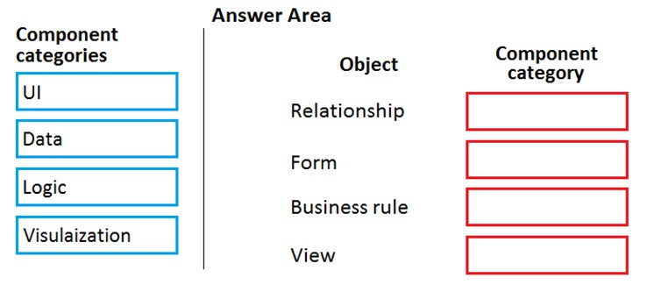

ANSWER

* A. Data – UI – Logic – UI
* B. UI – Logic – Data – UI
* C. Visualization – Logic – Data – UI
* D. UI – Logic – UI – Data
* E. Logic – Data – UI – UI
* F. Data – Logic – Logic – UI

# * - Question

HOTSPOT -  
You are creating a canvas app that will be used in several countries/regions.  
For each of the following statements, select Yes if the statement is true. Otherwise, select No.  
NOTE: Each correct selection is worth one point.  
Hot Area:  
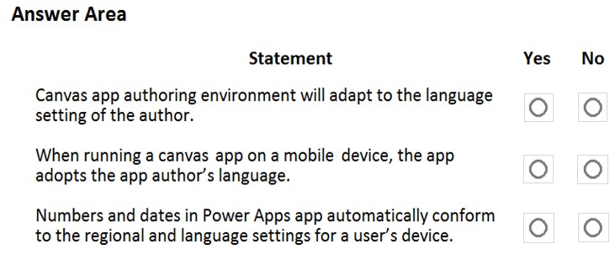

ANSWER

* A. Yes – Yes – Yes
* B. Yes – No – No
* C. Yes – No – Yes
* D. No – Yes – Yes
* E. No – No – No
* F. Yes – Yes – No

# * - Question

HOTSPOT -  
A company plans to build Power Apps portals.  
For each of the following statements, select Yes if the statement is true. Otherwise, select No.  
NOTE: Each correct selection is worth one point.  
Hot Area:  
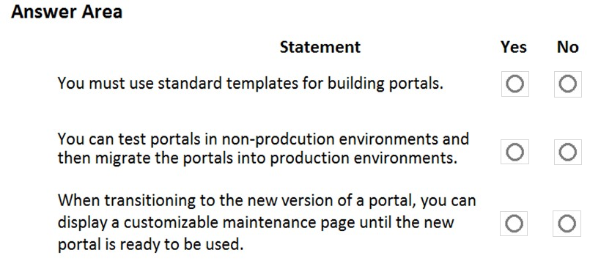

ANSWER

* A. Yes – Yes – Yes
* B. Yes – No – No
* C. Yes – No – Yes
* D. No – Yes – Yes
* E. No – No – No
* F. Yes – Yes – No

# * - Question

A company uses Dynamics 365 Supply Chain Management.  
You need to use Power Automate to automate the process of receiving and tracking raw materials.  
Which type of connector should you use?

ANSWER

* A. Common Data Service
* B. Dynamics 365
* C. Dynamics 365 for Fin & Ops
* D. Dynamic Signal

Dynamics 365 for Finance and Operations is now being licensed as Dynamics 365 Finance and Dynamics 365 Supply Chain Management.

# * - Question

A company performs on-site inspections and services for air industrial equipment.  
Field technicians must perform a series of maintenance checks every time they visit a customer site. Every technician performs maintenance tasks in a different order. Some technicians miss steps.  
You need to ensure that all technicians perform the same steps in the same order.  
What should you use?

ANSWER

* A. Business process flow
* B. AI Builder
* C. Business rule
* D. Virtual Agent

# * - Question

HOTSPOT -  
A company plans to use Power Apps to connect to a series of custom services. There are no connectors available for the custom services.  
For each of the following statements, select Yes if the statement is true. Otherwise, select No.  
NOTE: Each correct selection is worth one point.  
Hot Area:  
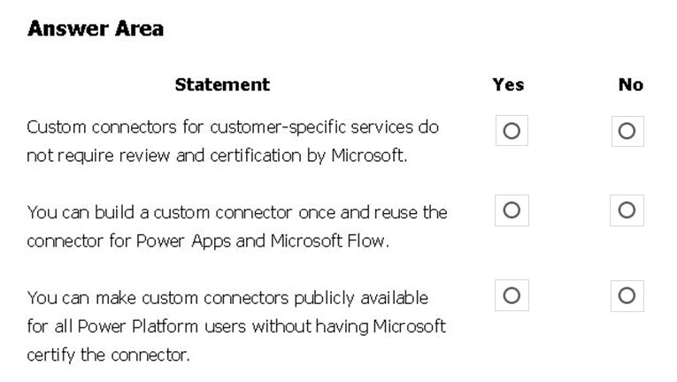

ANSWER

* A. Yes – Yes – No
* B. Yes – No – No
* C. Yes – Yes – Yes
* D. No – Yes – Yes
* E. No – No – No
* F. Yes – No – Yes

# * - Question

You need to use Microsoft Flow to perform data-management tasks when users interact with the sales opportunities in Dynamics 365.  
Which three types of triggers can you use? Each correct answer presents a complete solution.  
NOTE: Each correct selection is worth one point.

ANSWER

* A. record requested
* B. record deletion
* C. record creation
* D. record updated
* E. record selected

# * - Question

A company uses Dynamics 365 Supply Chain Management.  
When a sales order is created for one of the customers that a specific user manages, a Microsoft Outlook task must be created to remind the user to perform any follow up activities that are required.  
You need to implement the functionality to create Outlook tasks.  
Which two features should you use? Each correct answer presents part of the solution.  
NOTE: Each correct selection is worth one point.

ANSWER

* A. AI Builder
* B. Power Apps
* C. Business Events
* D. Microsoft Flow
* E. Common Data Service

# * - Question

HOTSPOT -  
A company uses a third party application and an approval process via email. At the end of the month, the IT department enters the data into Microsoft Excel to create pivot charts.  
The Excel pivot charts must use the same data source as Dynamics 365 Field Service to generate charts and reports.  
You need to recommend a solution.  
What should you recommend? To answer, select the appropriate configuration in the answer area.  
NOTE: Each correct selection is worth one point.  
Hot Area:  
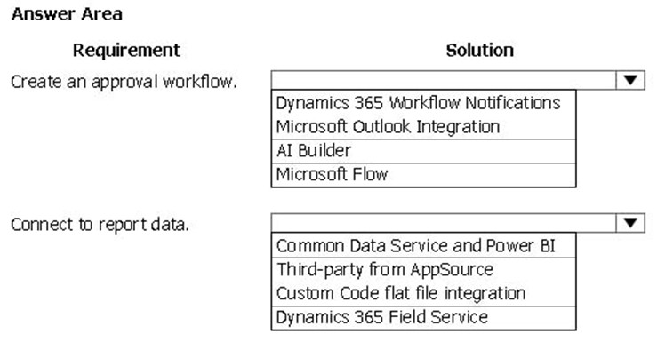

ANSWER

* A. Dynamics 365 Workflow Notifications – Dynamics 365 Field Service
* B. Dynamics 365 Workflow Notifications – Third-party from AppSource
* C. Microsoft Outlook Integration – Dynamics 365 Field Service
* D. AI Builder – Custom Code flat file integration
* E. Microsoft Flow – Dynamics 365 Field Service
* F. Microsoft Flow – Third-party from AppSource

# * - Question

This question requires that you evaluate the underlined text to determine if it is correct.  
A company requires that service representatives schedule customer visits every six months. Each service representative is required to enter a scheduled task for the next checkup as they are leaving a client site. A service representative wants to automate task entry by creating a business process flow that can be initiated from the service call screen on a phone.  
Review the underlined text. If it makes the statement correct, select "No change is needed." If the statement is incorrect, select the answer choice that makes the statement correct.

ANSWER

* A. No change is needed.
* B. a scheduled
* C. an instant
* D. an action

# * - Question

DRAG DROP -  
You build a flow using a template. You want to add support for additional business scenarios.  
You need to ensure that the new workflow does not break existing functionality.  
Which flow editing utilities should you use? To answer, drag the appropriate tools to the correct requirements. Each tool may be used once, more than once, or not at all You may need to drag the split bar between panes or scroll to view content.  
NOTE: Each correct selection is worth one point.  
Select and Place:  
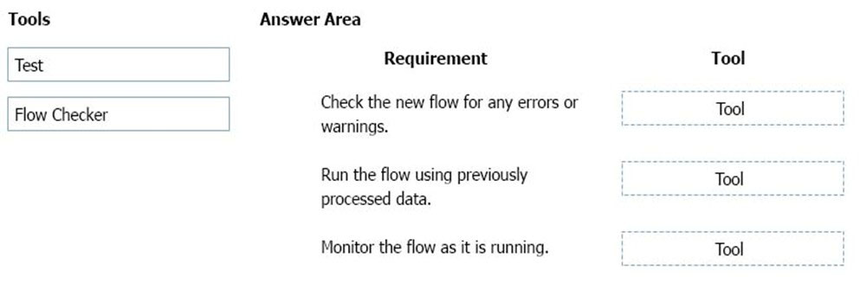

ANSWER

* A. Flow Checker – Test – Test
* B. Flow Checker – Flow Checker – Test
* C. Test – Flow Checker – Test
* D. Test – Flow Checker – Flow Checker
* E. Flow Checker – Flow Checker – Flow Checker
* F. Test – Test – Test

# * - Question

You use Power Automate for personal productivity.  
You often overwrite working flows by editing the definitions. You are unable to undo changes after saving a flow.  
You need to be able to revert a flow to the current state.  
Which two options can you use? Each correct answer presents a complete solution.  
NOTE: Each correct selection is worth one point.

ANSWER

* A. Export
* B. Rename
* C. Save As
* D. Share

# * - Question

You use Power Automate to create a flow that automatically sends email to a project manager when project team members mark a task as complete.  
Project team members are prematurely marking tasks as complete. You must add quality control into the process by sending an email to a project lead for confirmation that the task is in fact complete before sending the email to the project manager.  
You need to modify the flow.  
Which component should you use?

ANSWER

* A. a process argument
* B. a condition
* C. an expression
* D. a trigger
* E. an action

# * - Question

A company uses Microsoft Flow.  
Each time a work order is created, a service manager must review and approve the work order before a worker is dispatched.  
You need to create a flow to enforce the process.  
What should you create?

ANSWER

* A. plug-in
* B. approval flow
* C. business rule
* D. team flow
* E. instant flow

# * - Question

DRAG DROP -  
You plan to use Microsoft Flow to monitor what people are saying about your company's products. You store the feedback for research and development purposes.  
You need to recommend Flow components to use for the solution.  
To answer, drag the appropriate components to the correct requirements. Each component may be used once, more than once, or not at all. You may need to drag the split bar between panes or scroll to view content.  
NOTE: Each correct selection is worth one point.  
Select and Place:  
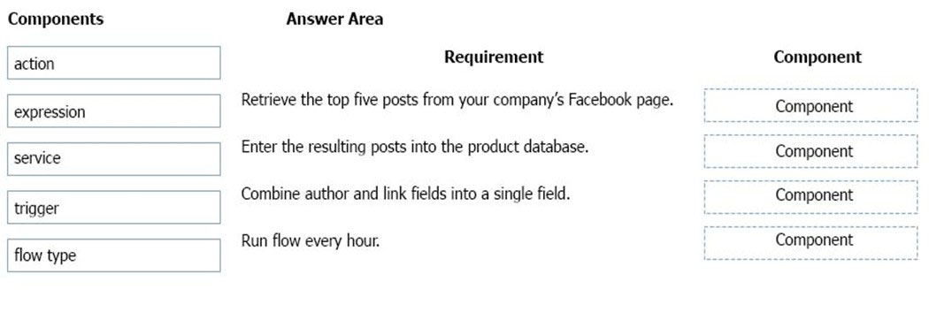

ANSWER

* A. trigger – action – expression – flow type
* B. trigger – service – expression – flow type
* C. trigger – action – service – flow type
* D. trigger – action – expression – service
* E. expression – trigger – service – flow type
* F. expression – trigger – action – flow type

# * - Question

You are new to working with Microsoft Flow. You create a flow that extracts birth dates for users and then sends a birthday greeting email to users on their birthday.  
The flow does not properly extract birth dates.  
Where should you make changes?

ANSWER

* A. Connectors
* B. Expression
* C. Templates
* D. None

# * - Question

DRAG DROP -  
A company plans to use Power Automate to automate tasks.  
Match each flow type to its description. To answer, drag the appropriate flow type from the column on the left to its description on the right. Each option may be used once, more than once, or not at all.  
NOTE: Each correct match is worth one point.  
Select and Place:  
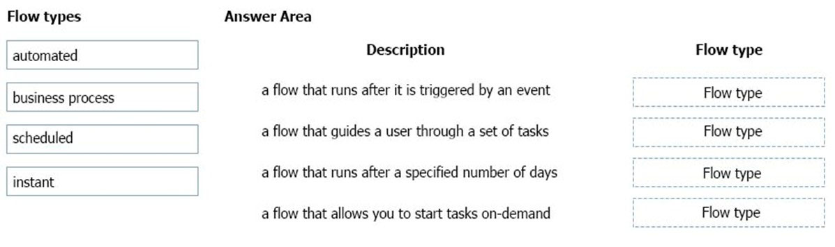

ANSWER

* A. automated – business process – scheduled – instant
* B. business process – automated – scheduled – instant
* C. automated – scheduled – business process – instant
* D. automated – instant – business process – scheduled
* E. scheduled – automated – business process – instant
* F. instant – automated – business process – scheduled

# * - Question

HOTSPOT -  
A company plans to synchronize data between Dynamics 365 Supply Chain management and Dynamics 365 Sales.  
For each of the following statements, select Yes if the statement is true. Otherwise, select No.  
NOTE: Each correct selection is worth one point.  
Hot Area:  
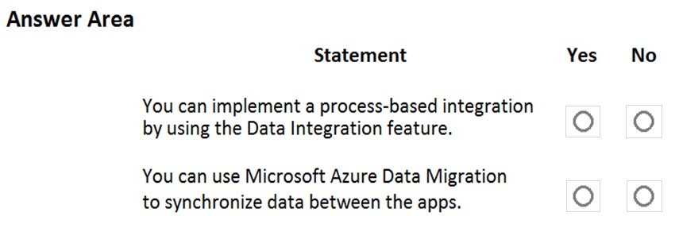

ANSWER

* A. Yes – No
* B. No – No
* C. Yes – Yes
* D. No – Yes

# * - Question

A company has a website. The website includes a form that allows the company to collect information about leads.  
You need to set up an automated workflow to create leads in Dynamics 365 Sales when leads are created on the company's custom website.  
What should you create?

ANSWER

* A. Task Flow
* B. Power Automate flow
* C. Dynamics 365 workflow
* D. Business Process Flow

# * - Question

A company builds and sells residential apartments. The company uses Dynamics 365 Sales to manage sales opportunities.  
Management must receive notifications on their mobile devices when sales opportunities are created.  
You need to select recommend Power Platform components to address the requirements.  
Which two components should you recommend? Each correct answer presents part of the solution.  
NOTE: Each selection is worth one point.

ANSWER

* A. Common Data Service connector
* B. Power BI
* C. Power Automate
* D. AI Builder

# * - Question

A company uses Microsoft 365, SharePoint Online, and Dynamics 365 Sales.  
You need to recommend tools to build a solution that meets the following requirements:  
  
  
Synchronize data daily -  
✑ from an external Microsoft SQL Server instance.  
✑ Send an out-of-the box report automatically to specific company executives.  
✑ Ensure that opportunities over a specified amount are approved by a sales manager.  
Which two tools or components should you recommend? Each correct answer presents part of the solution.  
NOTE: Each correct selection is worth one point.

ANSWER

* A. Microsoft Excel
* B. Microsoft Word
* C. Power BI
* D. Common Data Service
* E. Power Automate

# * - Question

HOTSPOT -  
A company is using Power Automate to automate business processes.  
You need to recommend triggers for Instant flows.  
What trigger types should you recommend? To answer, select the appropriate options in the answer area.  
NOTE: Each correct selection is worth one point.  
Hot Area:  
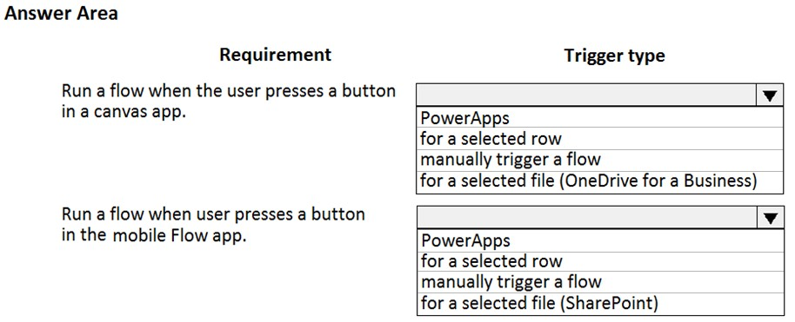

ANSWER

* A. PowerApps – manually trigger a flow
* B. for a selected row – manually trigger a flow
* C. PowerApps – for a selected file (SharePoint)
* D. manually trigger a flow – for a selected row
* E. for a selected file (OneDrive for a Business) – for a selected file (SharePoint)
* F. PowerApps – PowerApps

# * - Question

A company uses Dynamics 365 Supply Chain Management.  
You need to use Microsoft Flow to automate the process of receiving and tracking raw materials.  
Which type of connector should you use?

ANSWER

* A. Common Data Service
* B. Dynamics 365
* C. Dynamics 365 for Fin & Ops
* D. Dynamic Signal

# * - Question

A company uses Dynamics 365 Supply Chain Management and Dynamics 365 Finance.  
Account data must be synchronized between the two system.  
You need to ensure that the synchronized data is stored in one place.  
What should you use?

ANSWER

* A. Azure IoT Central
* B. Azure Active Directory
* C. SQL Server
* D. Common Data Service

# * - Question

What is a benefit of deploying Microsoft 365 and Dynamics 365 apps in the same tenant?

ANSWER

* A. Use Common Data Services to connect to application data.
* B. You only need to set up groups in Microsoft 365 for permissions to all data.
* C. Users can access both Microsoft 365 and Dynamics 365 by using Single Sign-on (SSO).
* D. None